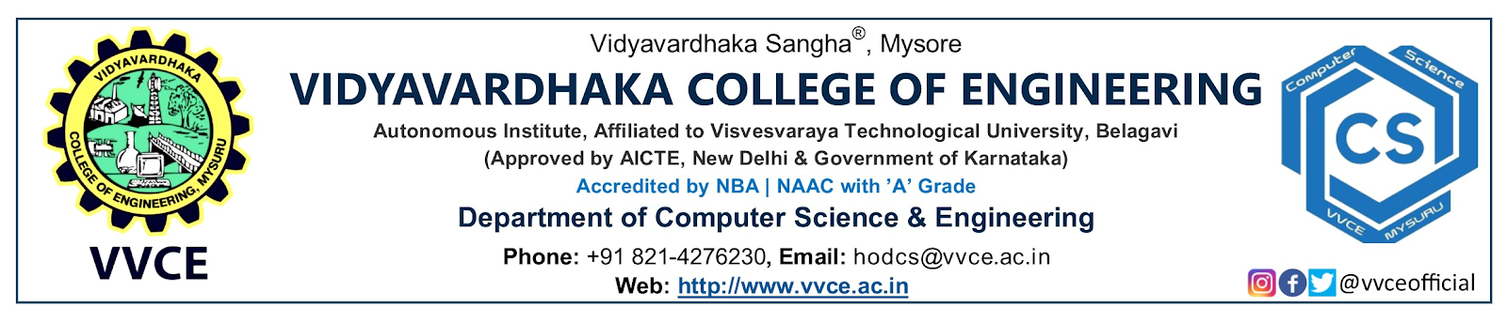



**09th November 2022**

From

Chethana HT

Asst Professor, Dept. of CSE

OSL Coordinator, Open Source Lab

VVCE, Mysuru

Through

Induction Committee

VVCE, Mysuru

To

The Principal

VVCE, Mysuru

Dear Sir,

Sub: Requisition for the approval and sanction of budget for the conduction of OSL club activities during the induction program 2022-23

With respect to the above subject, I request you to approve and sanction the budget of **Rs.6,980/-** for the conduction of activities from Open Source Lab of Computer Science and Engineering during the induction program 2022-23, for the first-year students. Kindly do the needful.

Thanking you

Yours sincerely,

**Chethana HT**

**Encl.**

Budget

**Open Source Lab – Induction Requirement**

With the Oncoming batches of Students having induction program, we have been allotted to engage with 8 batches of 80 members each. Kindly consider the request and give permission to utilize the department association fund (TECSA).

**Estimated expenditure is as given below.**

| **Estimated Expenditure** | | |
| --- | --- | --- |
| **Sl No.** | **Details** | **Amount**  **(Rs.)** |
| 1. | Stickers (4/- * 700) | 2800/- |
| 2. | Badges (17/- * 100) | 1700/- |
| 3. | Chocolates (10/- * 100) | 1000/- |
| 4. | Refreshments  (30/- * 8 batches * 7 members) | 1680/- |
|  | **Total** | **7180/-** |
| **Seven Thousand One Eighty Only/-** | | |

**Financial Approval Committee**

| **Members** | **Approved** | **Disapproved**  **Reason for disapproval** | **Signature** |
| --- | --- | --- | --- |
| Dr. Paramesha K |  |  |  |
| Dr. Janahvi |  |  |  |
| Ms. Radhika A D |  |  |  |
| Mrs. Shraddha C |  |  |  |

**Coordinators Dr. Pooja M R**

**Chethana H T HOD, CSE**

**Lakshmi**

**Vision:** The Department of Computer Science and Engineering shall create professionally competent and socially responsible engineers capable of working in global environment